**Git & GitHub Project**

Problem:

you are asked to take screenshots for each step in the instructions section, then push these screenshots to the GitHub repository.

**Instructions & Solutions:**

* 1. Create a folder called learn_git.

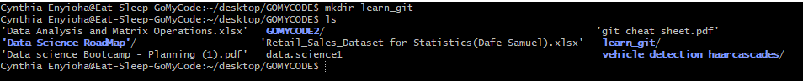

* 1. Cd (change directory) into the learn_git folder.

* 1. Create a file called third.txt.

* 1. Initialize an empty git repository.

* 1. Add third.txt to the staging area.

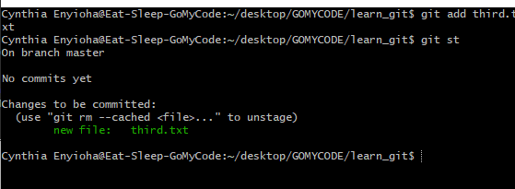

* 1. Commit with the message "adding third.txt".

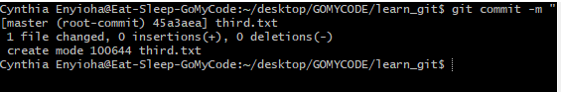

* 1. Check out your commit with git log.

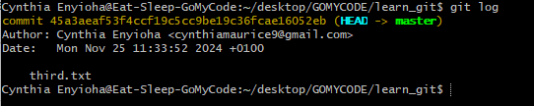

* 1. Create another file called fourth.txt.

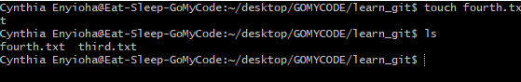

* + 1. Add fourth.txt to the staging area.

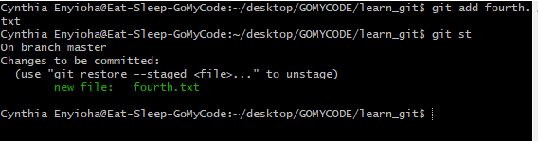

* + - 1. Commit with the message "adding fourth.txt"

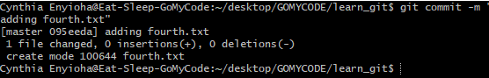

* + - 1. Remove the third.txt file.

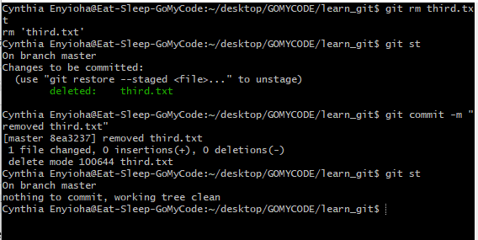

12. Add this change to the staging area. (Using the command "git add . "

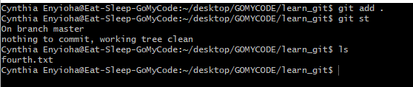

1. Commit with the message "removing third.txt".

1. Check out your commits using git log.

1. Change your global settings to core.pager=cat - you can read more about that here

core.pager=cat, tells Git to output everything directly to the terminal without using a pager, which can be useful to avoid scrolling.



1. Write the appropriate command to list all the global configurations for git on your machine.

17. You can type git config --global to find out how to do this

